**Governor Information**



**Miss Hayley Gilmour**

Parent governor and Chair (since 2022)

Governor Term

Waterside primary school 3.5 years (2020)

St Peter's CofE middle school 2 years

Interests/area of expertise

Advocate for change and effective communication, processes, and practices.

Governor vision for Waterside Primary School

I've been a parent to a child within Waterside Primary school since 2019, a governor since 2020 and chair of governors since 2022. I am committed in supporting the school though change and the new ways of working since covid. My role within the governing board to ensure the school and staff are well equipped to continue delivering excellent opportunities to support learning and development. I am truly grateful for all the staff at Waterside creating such a supportive and exciting place for our children to thrive.

**Mr Don Naylor**

Co-opted Governor and Vice chair

Governor Term

I became a Community Governor in the first half of the 2000s. I took the place of a colleague of mine from St Johns Church who was retiring from the Governing Body.

Interests/area of expertise

I have skills in leadership and management from being a churchwarden and PCC member at St Johns. Also, in my career as a Professional Engineer in Research and Development I had acquired skills in project planning, objectivity, critical analysis, etc.

Governor vision for Waterside Primary School

When I first became a governor, the main focus was on providing a service to the good of the community, in which the school existed. This has always been something that was important to me and so I signed up to ensure that the children in those schools had the best education possible in a safe environment which was conducive to effective learning.

**Mrs Emma Moakes**

Headteacher Governor

Governor Term

I have officially been Headteacher/governor since January 2018, although I have been with the school 18 years and since it amalgamated.

Interests/area of expertise

I have taught across the primary phase and have been teaching since 1995.  I have a teaching degree with drama as a specialism and this is a real passion for me.  I also have a Masters in educational leadership.  Other than drama I love the creative arts and love the confidence and self-esteem this promotes.

Governor vision for Waterside Primary School

I am passionate about the Waterside Primary community and about providing our pupils with positive relationships and rich experiences.

**Mrs Lisa Taylor**

Co-opted Governor

Governor Term

Since November 2021

Pupil Premium lead (Since September 2022)

SEND lead (Since March 2022)

Chair of Curriculum and standards committee (Since September 2022)

Wider curriculum lead Since September 2022)

Chair of HTPM committee (Since September 2022)

Interests/area of expertise

I have a law with criminology degree and an MSc Criminology and Criminal Justice. I have worked within many youth services in Southampton. The clear vision I had was to help redirect young people from the Criminal Justice System. I did this professionally in many different ways. Although primarily my main focus was to help move young people away from the CJS, I soon learnt it was more about helping young people build happier futures for themselves. This became my passion and still is. Whether it was helping teach dance to people with limited mobility or different abilities, teaching children to read, being an empathetic ear to a young person who feels lost or helping young people feel more positive about themselves and believe “I CAN DO THIS” this is what I love to do.

IN 2012 I created WHY dance delivering dance classes all over Southampton for a number of schools, and services. Working with multiple agencies I learnt the value of collaboration. Built around the concept of inclusively, promoted “Wellbeing and Health for You through dance” and was for tailored all different abilities, motilities, and ages.

Governor vision for Waterside Primary School

Joy Fiddaman is a neighbour and friend of mine. Joy has watched my boys grow up and we have had plenty of discussions around the boys and our backgrounds. I knew Joy was a Governor at Waterside Primary School and later on Joy asked if this was something I would be interested in. I jumped at the chance, as to be more involved in Theos school, was a dream. At the start I didn’t initially have much of an idea as to what the Governing board did, but knew it was an important role. I love researching learning, being part of the school and feeling that hopefully I can make a difference



**Mr Roger Guy**

Local Authority Governor

Governor Term

I was appointed to the Governing Body as the Local Authority representative in March 2015 during the rebuilding of the School.

During this time, I have been the Chair of the Governing Body, chair of the Finance Committee and have served as a member on several of the other committees.

Interests/area of expertise

I have experience in Financial and Maintenance Management gained as a senior manager in the Power Industry.

Governor vision for Waterside Primary School

As part of my various roles during my career I was responsible for the training of apprentices and other staff. This gave me the insight into the value of education for future careers of individuals. As a consequence, I have an interest in ensuring that all children are given the best possible education and this I can do by serving on the Governing Body.

**Mrs Katie Shimman**

Parent Governor

Governor Term

10 years

I have also been a staff governor at Harrison Primary School and Abbotswood Junior School.

Interests/area of expertise

I am a teacher, so although I find the curriculum side of governance interesting, I am on the finance committee, and I find it fascinating understanding the budgeting decisions schools have to make. I am also the Safeguarding Link Governor.

Governor vision for Waterside Primary School

My son attends the school, so I wanted to offer my support to the school team and other governors. As a staff governor, I've always been a part of the curriculum team. However, as a parent governor, I get to be on the Finance and Premises Committee which has given me the opportunity to learn so many new and important things that are not only relevant to me as a teacher, but also as a parent. I am incredibly proud to be a part of the Waterside Primary School Community and I hope to continue to support for as long as possible.

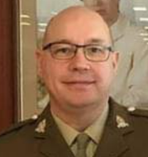

**Mr Paul Banyard**

Co-Opted Governor

Governor Term

7 years

Interests/area of expertise

Currently Taring Governor.  Finance - wide experience in public funds.

Governor vision for Waterside Primary School  
I felt it was time to put to put something back to the local community and help provide the best possible education to the children.

**Mr Chris Shimman**

Co-opted Governor

Governor Term

3 years

Interests/area of expertise

I am interested in the general running of the school. In particular, the impact the school’s finances can have on the children’s education and welfare.

Governor vision for Waterside Primary School

As a school governor, I can actively contribute to and support the development and improvement of the school. I can use my time as governor to influence policies, be a part of decision-making processes, and the play a part in the overall direction of the school to ensure that all children can be the best that they can be.

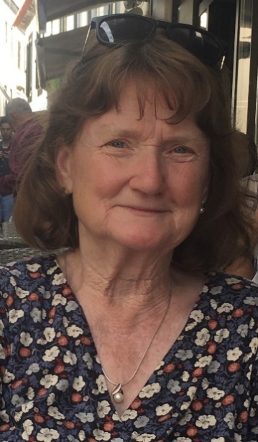**Mrs Joy Fiddaman**

Co-opted Governor

Governor term

6 years (2017)

Interests/area of expertise

My career was in primary teaching in London, Oxfordshire, Alaska, and Wiltshire. I held headships in five different schools.

Governor vision for Waterside Primary School

I have never lost my enthusiasm for wanting to see children achieve their very best, and for school to provide an exciting, safe environment to nurture their talents. My initial visit to Waterside, meeting staff and pupils made me certain that I wanted to be a part of this team. I have seen the school go from strength to strength, always keeping the child at the centre. It is a privilege to be part of a whole school network, working together to achieve the best outcomes for all our pupils.

**Dr Beth George**

Co-opted Governor

Governor Term

A few months - May 2023

Interests/area of expertise

Professionally as a senior clinical psychologist working at University Hospitals Southampton. I have an extensive of understanding of mental health, well-being, safeguarding and neurodiversity. My role also requires both communication and leadership skills. I also have experience of teaching abroad, including teaching English and as a teaching assistant working one-to-one with SEND children. I also regularly teach post-graduation students as part of my current role. Personally, as a military spouse I appreciate first-hand the unique challenging faced by military children and their families. As part a dual heritage family (English-Nigerian), I have a more personal insight and connection to issues such as diversity, equality, and racism. As someone with dyslexia I know very well the challenges school and learning can have and yet with the right support and determination you can achieve your goals.

Governor vision for Waterside Primary School

I have always enjoyed volunteering and consider it important to give back to the community. With our youngest child joining Waterside this year it seemed to perfect time to join the governor board with the hope to use both my professional and personal experience to support all children to have the best possible experience, educationally and otherwise, at Waterside Primary School.